Investigating the effect of pH on amylase activity
This practical allows you to:
- discover how pH affects the rate of an enzyme controlled reaction
- evaluate the experimental procedure

Procedure
SAFETY:
Follow your teacher’s instructions for handling the solutions.
Wear eye protection when handling the iodine solution.

Investigation
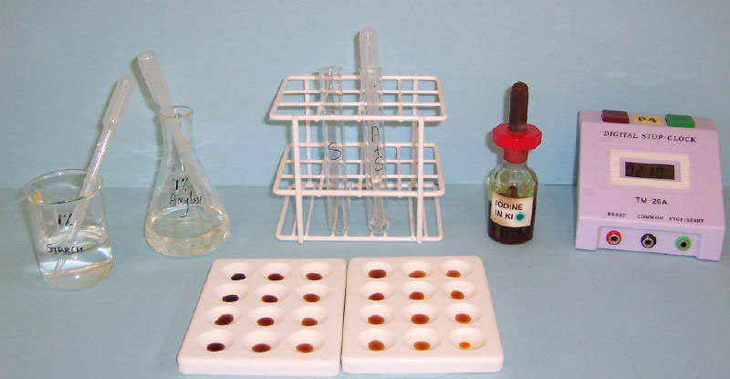
- Place single drops of iodine solution in rows on the tile.
- Label a test tube with the pH to be tested.
- Use the syringe to place 2 cm³ of amylase into the test tube.
- Add 1 cm³ of buffer solution to the test tube using a syringe.
- Use another syringe to add 2 cm³ of starch to the amylase/ buffer solution. Start the stop clock and leave it on throughout the test. Mix using a plastic pipette.
- After 10 seconds, use the plastic pipette to place one drop of the mixture on the first drop of iodine. The iodine solution should turn blue-black. Squirt the rest of the solution in the pipette back into the test tube.
- Wait another 10 seconds. Then remove a second drop of the mixture to add to the next drop of iodine.
- Repeat step g until the iodine solution and the amylase/ buffer/ starch mixture remain orange.
- You could prepare a control drop for comparison with the test drops. What should this contain?
- Count up how many iodine drops you have used, each one equals 10 seconds of reaction time.
- Repeat the whole procedure with another of the pH buffers or pool your results with others in your class.
- Collect repeat data if there is time.
- Plot a graph of time taken for starch to break down against pH.
OR
Calculate the rate of the reaction by calculating 1 ÷ time. Plot rate of reaction against pH.

QUESTIONS
- It is important to add the buffer to the enzyme before adding the starch. Why is this?

- How does a control help you with the colour comparison?

- Are there any anomalies or inconsistencies in your results?

- Do you think your results are reliable? How would repeating the investigation help you to check the reliability?

- Describe your graph(s). What is the effect of pH on the enzyme controlled reaction?

- Explain how pH affects enzyme reactions.

- How could you improve this investigation?

- Describe how you would modify this activity to investigate the effect of temperature on the rate of break down of starch by amylase.

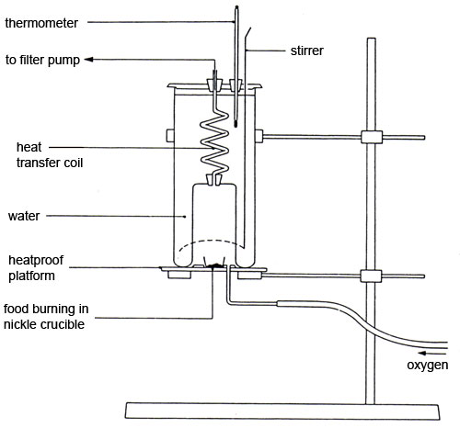

ANSWERS
- It is important to add the buffer to the enzyme before adding the starch because the reaction will start as soon as the enzyme meets the starch. If the buffer is not already in, you will be changing the pH after the reaction has started and so the results will not be valid.

- A control makes it easier to be sure that all the starch is gone as it shows you the colour of the iodine solution diluted with a drop of water (which we are sure contains no starch).

- Students may have identified anomalies or inconsistencies.

- The results are reliable if they are consistent from one group to another, or if one repeat after another gives a very similar result.

- The enzyme-controlled reaction will be fastest at a particular pH – the optimum for the enzyme – and slower at pHs above and below this.

- pH affects enzyme reactions because it affects the detailed structure of the active site of the enzyme. Amino acids (which make up proteins) are strongly affected by pH as they can readily react with both acids and alkalis. If the shape or polarity of the active site changes, that will alter its effectiveness as a catalyst.

- Students may have ideas how to improve the investigation.

- To investigate the effect of temperature on the rate of breakdown of starch by amylase use similar quantities of reagents, but equilibrate all in a water bath at a fixed temperature before mixing. Try at a range of temperatures.

